Cheese
- The king starts the game by throwing the ball and hitting the cheese area to person number two.
- Person number two has to hit the ball before it hits the ground second time.
- Person number two shoots the ball to any one of the others. Etc.
- The ball must always hit within the square and never in your own area.
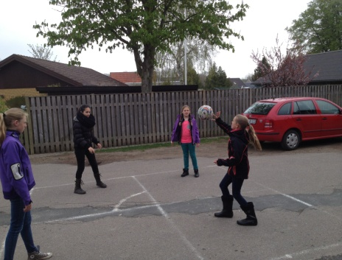
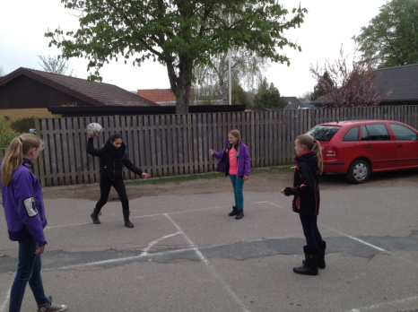

You die if you:
- Hit your own area with the ball
- Are hitting the ball out of the square
- The ball goes to the ground twice in your own area
- If you can’t reach the ball
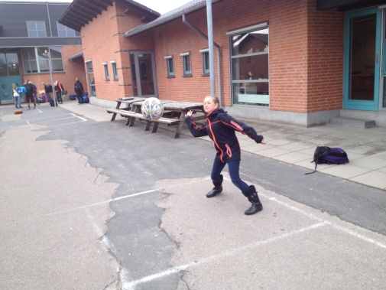
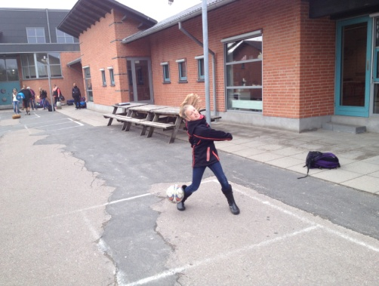

Two men in front of a widow
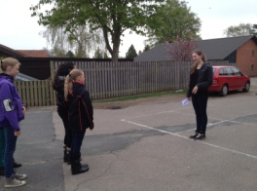
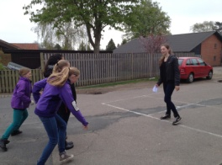
- The widow starting the game by shouting: “Two men in front of widow, run”
- This is the signal for the pair in the end of the line to run.
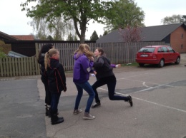
- They have to try to reach each other’s hands again before the widow catches one of them
- If your partner is caught you are the next widow

