COMENIUS PROJECT 2012-13



**“The joy of exploring village lives”**

CHRISTMAS TRADITIONS

I.C.S. “L. Pirandello”- Pesaro- Italy

classes 4 and 5 – teacher: Bernabucci Chiara

**“Christmas in Candelara: the village of candles!”**

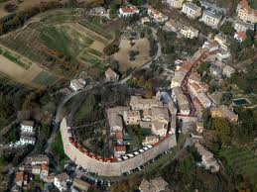

Candelara is a small ancient medieval village on the hills around the city of Pesaro, in the Marches.

[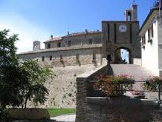](http://www.google.it/imgres?hl=it&biw=1280&bih=683&tbm=isch&tbnid=lq5oFf7zI4YizM:&imgrefurl=http://www.youtube.com/user/ProlocoCandelara&docid=73EZKuyLXaJGcM&imgurl=https://lh6.googleusercontent.com/-gvl04zY20eY/AAAAAAAAAAI/AAAAAAAAAAA/keCG_Oh5GSU/s48-c-k/photo.jpg&w=276&h=207&ei=8gY4UpGwHNH64QT6-IH4Bw&zoom=1&ved=1t:3588,r:74,s:0,i:313&iact=rc&page=4&tbnh=165&tbnw=220&start=60&ndsp=23&tx=124&ty=94)

Christmas is special in Candelara as you can find the first Italian Christmas market…

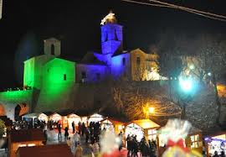 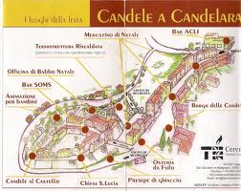

… called “Candele a Candelara”, entirely dedicated to candles, as the name of this village is due to candles. This market takes place the first two weekends of December.

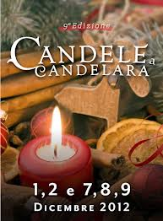 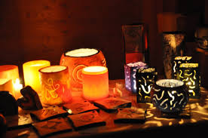

Lots of stands sell also many other handmade Christmas gifts.

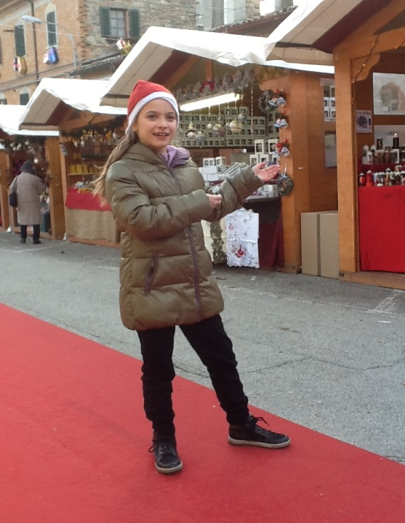

There are many different attractions in Candelara like the paths of cribs where you can admire natives made by skilled craftsmen coming from all over Italy.

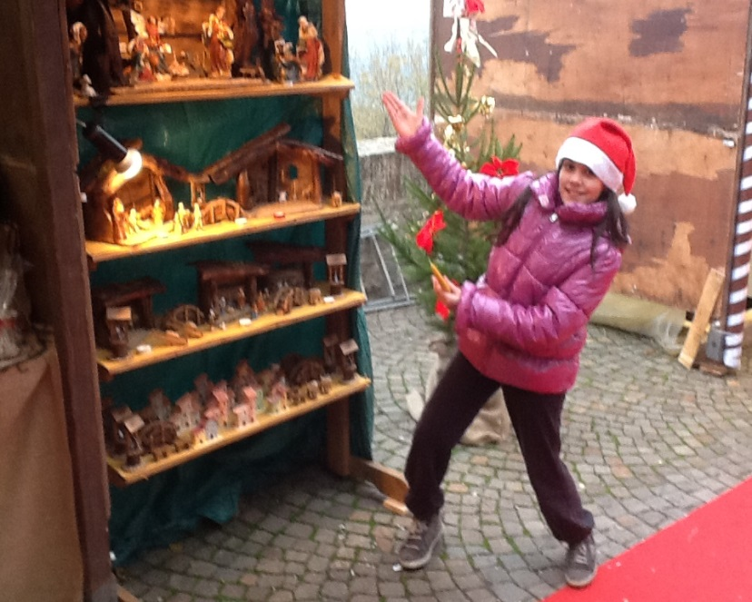

Walking along the narrow streets visitors can also see iron sculptures that represent the characters of nativity all decorated with candles of course!

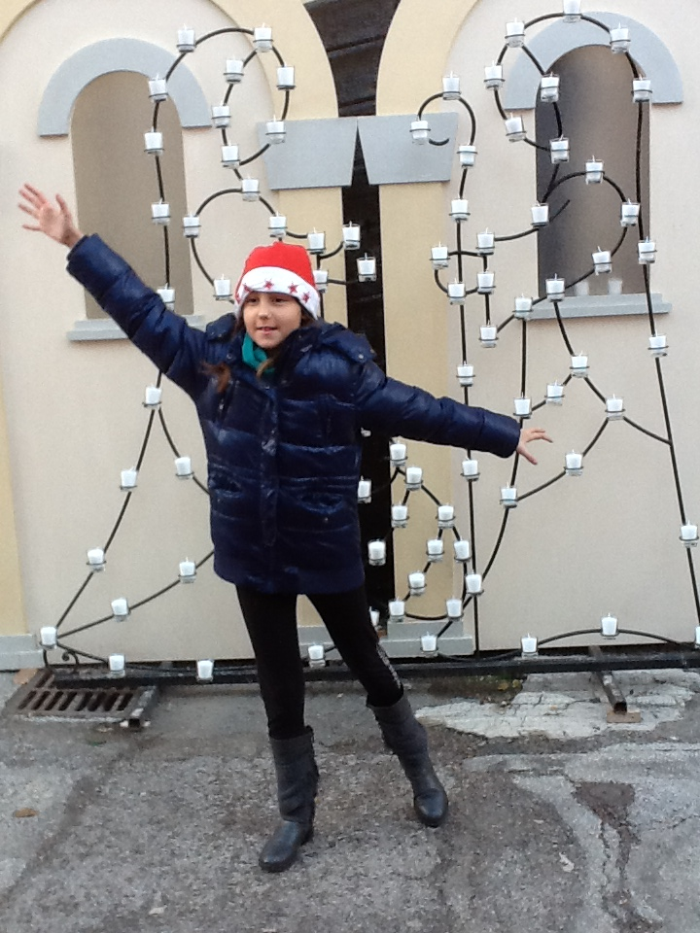 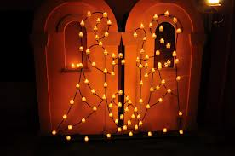

Visitors also have the opportunity to watch live the preparation of candles, strictly made of beeswax, as it happened in the Medieval Age.

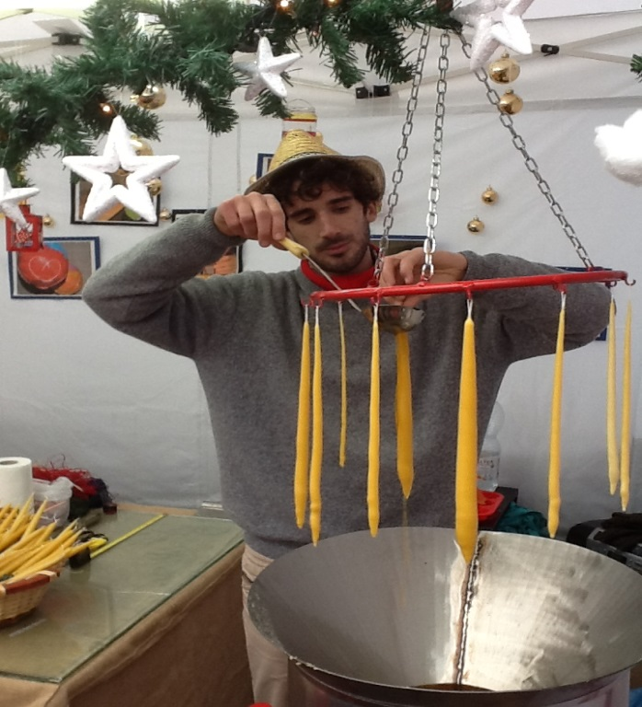

Candelara is an ideal place for children too as there is Santa’s workshop for them. Kids can create candles and many other Christmas decorations.

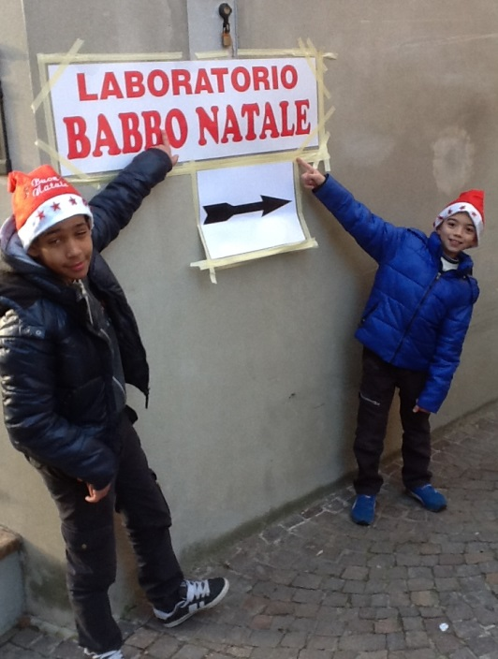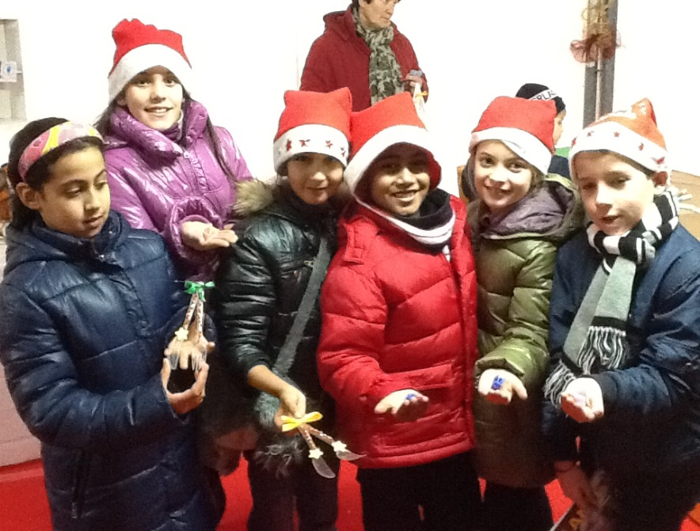

They can also have the possibility to meet Santa Claus along the streets…

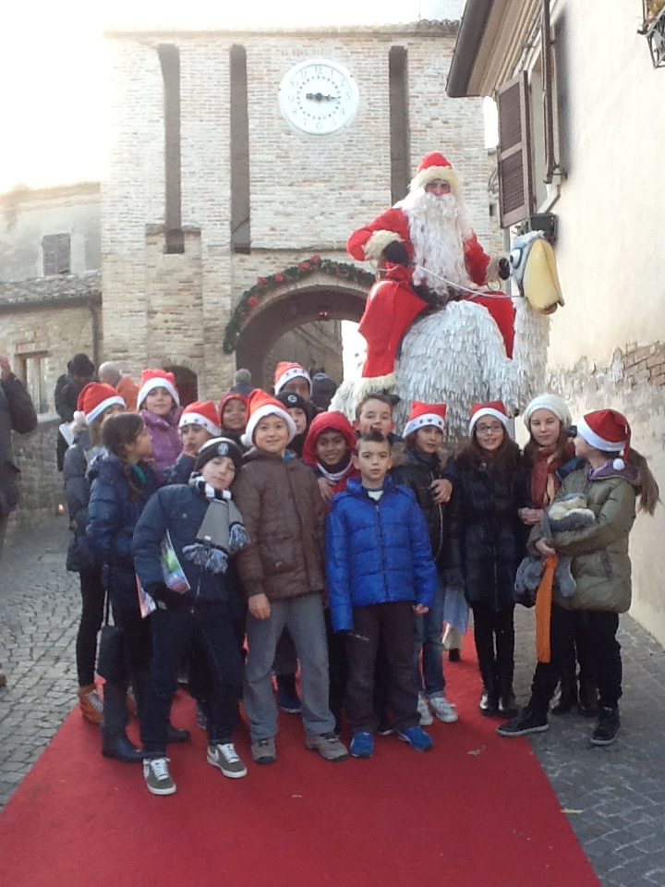

and many others funny Christmas characters…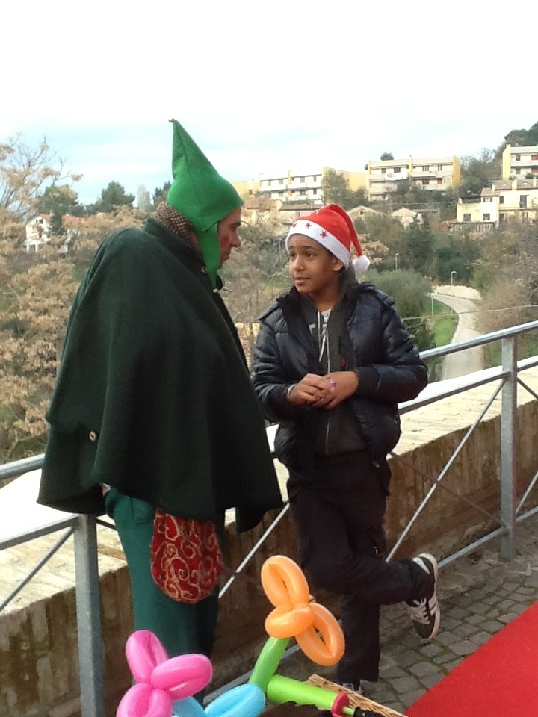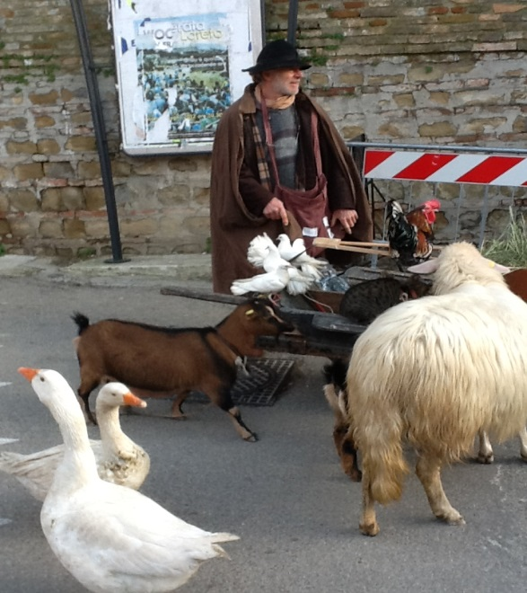

There is also a Santa Claus musical band playing bagpipes, drums... that will delight you with Christmas typical songs.

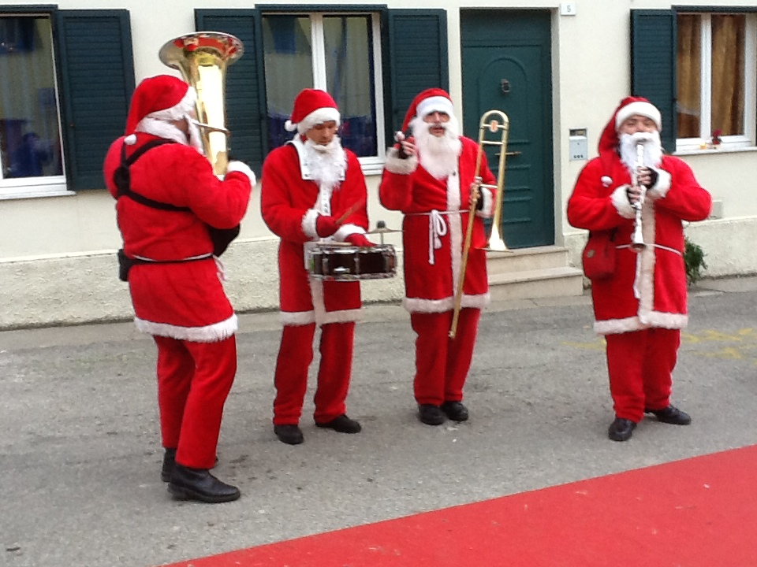

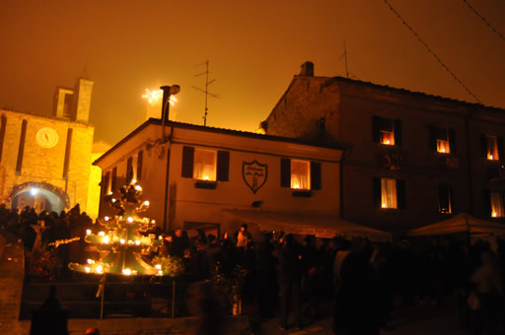Candelara becomes really magic in the evening when the artificial light is turned off for 3 planned shutdowns, lasting 15 minutes each, and the village is utterly illuminated by the warm light of candles.

The view and the atmosphere are really amazing!

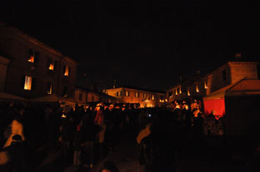

**So... enjoy Christmas in Candelara!!!**