Comenius Project 2012-2013
‘The Joy of Exploring Village Lives’
Festivities and traditions: The Festival of the Trees and of the local products
‘FROM EARTH TO THE HEAVENS’
Mombaroccio 6 and 7 April 2013
Class 1, 2, 3 A Secondary School “F.Barocci”- Mombaroccio
Teacher: Mrs Li Puma Cristina

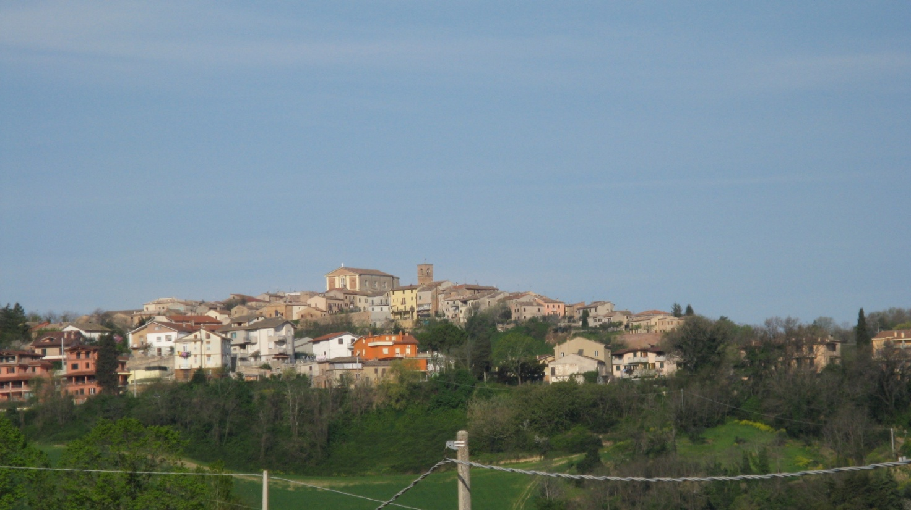

This is an event in spring time which celebrates nature.
It takes place in the town square of Mombaroccio – a nice village on the hills near Pesaro in the region Marche.
In the town centre you can find local street markets of beautiful handcrafts and food stalls.

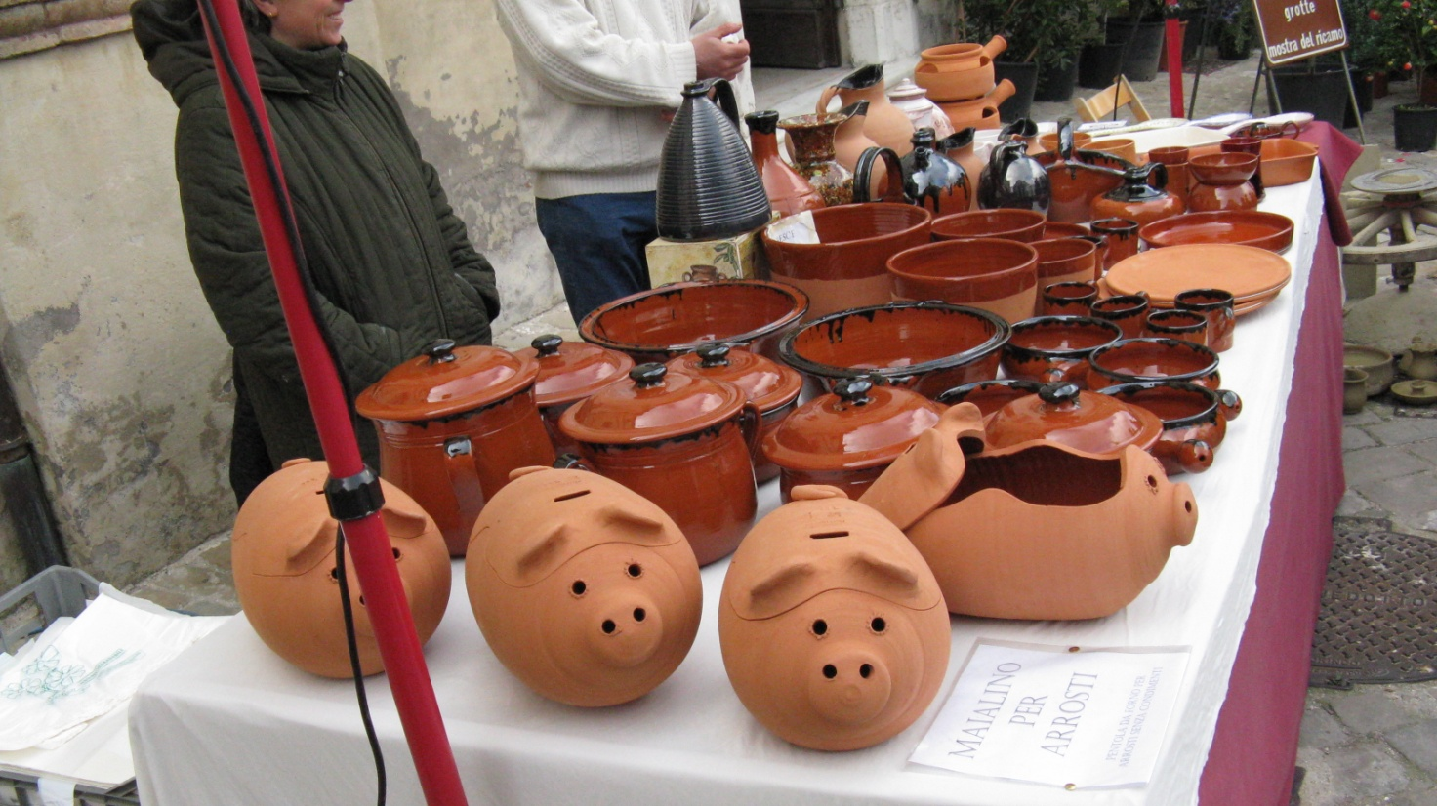
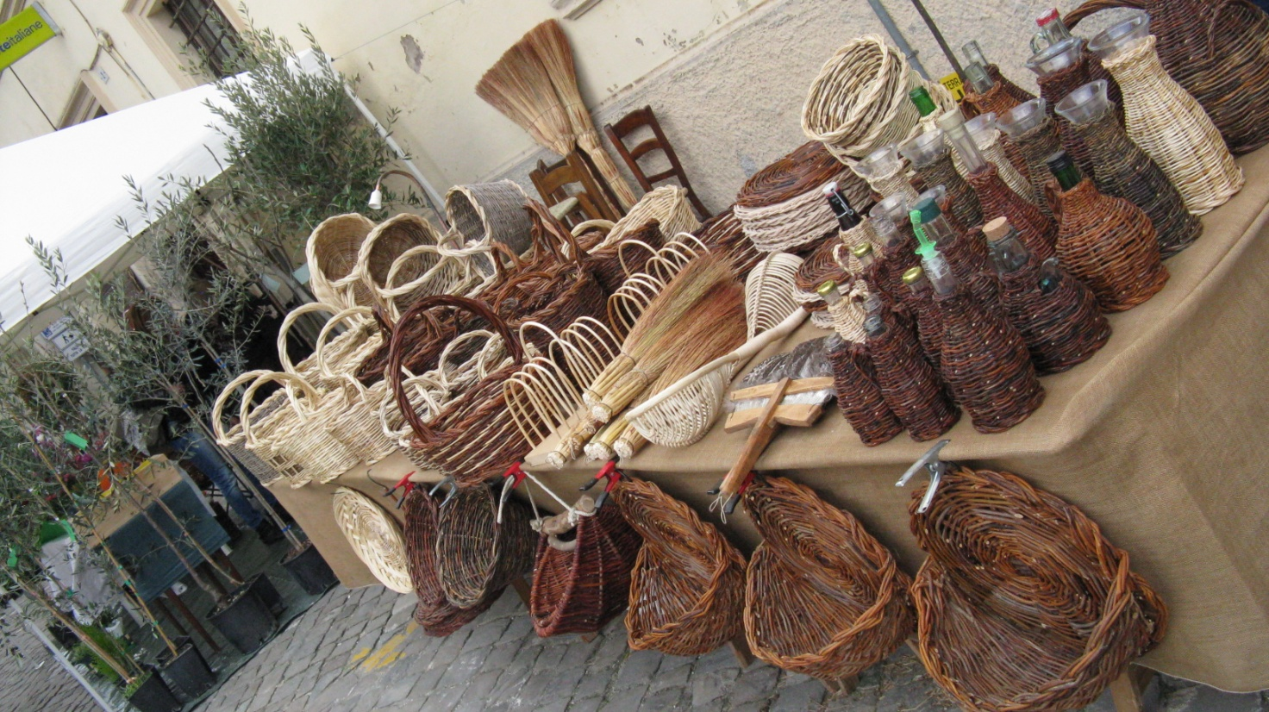
The exhibition of the trees, the wood carving and the tree-climbing are also part of this event.
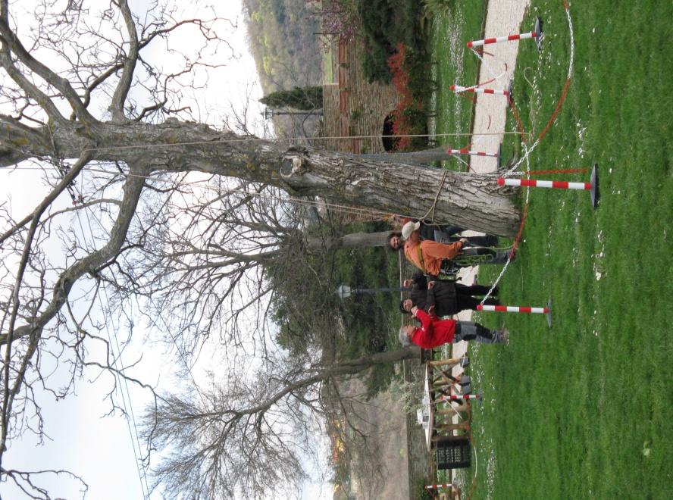
For the joy of children there are also games and animation, as well as music and the tasting of the local produce.
The students of the Primary and Secondary School are an active part of this festival. This year they have taken part with a language activity of ‘Expressive Reading’ of an extract from the book“The Man who Planted Trees” by Jean Giono.
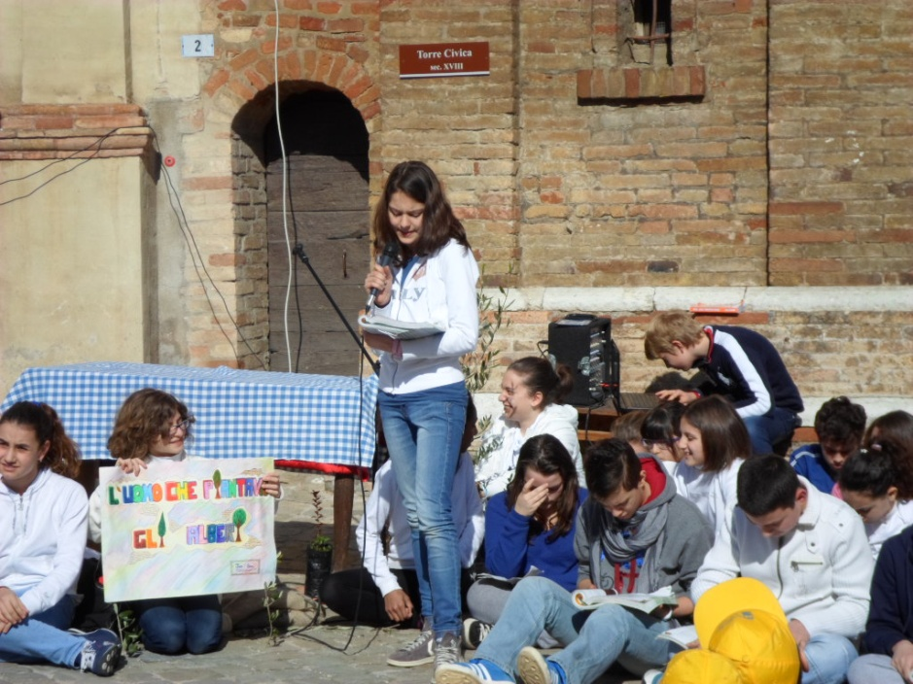
The Art activity called ‘The Impressionist Tree’ and ‘The tree in the texture technique’ has seen the realization of amazing drawings.
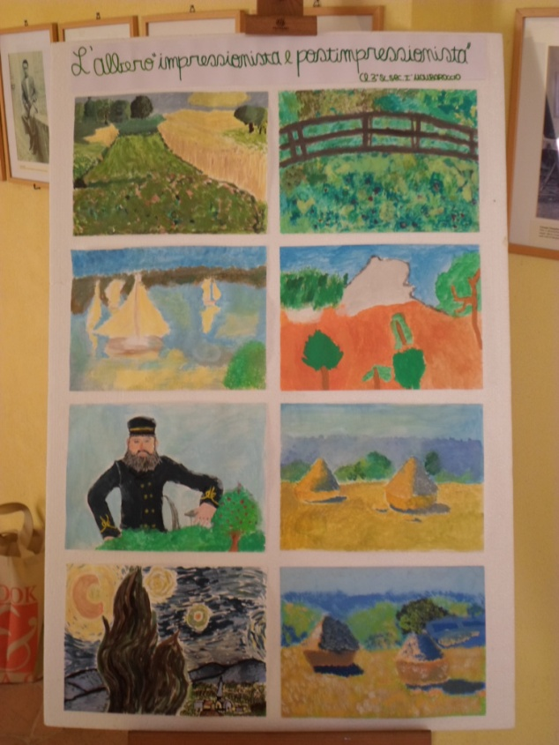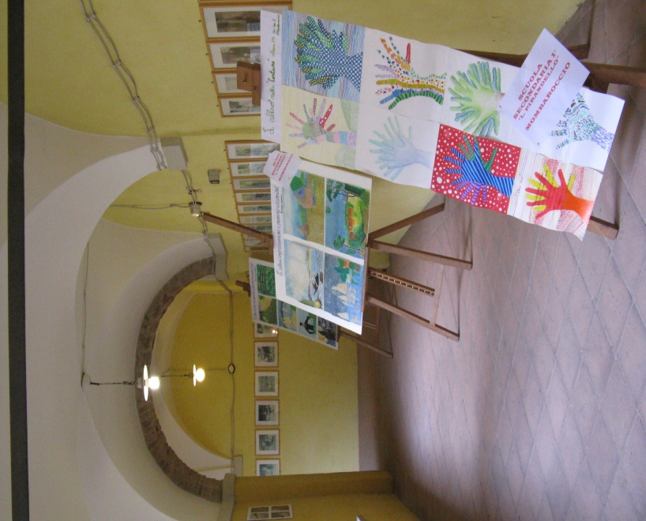
This year we have also had the pleasure to get a second best place at the National Literary Competition of the New Active Writing thanks to the 12-year-old Sara Spadoni who wrote the poetry “Oh, my tree…”

I can see you from my window
Your branches stretched out into infinity.
You look beaten
But there is a certain sweetness in your colours
A symphony of brown, yellow, red and orange
Loosing your leaves to the rhythm
Of the branches dancing in the wind.

